**HOTEL MANAGEMENT SYSTEM**

**1. Introduction**

The hotel management system is designed to streamline and enhance the booking process for various hotel services, specifically focusing on dining, event hall reservations, and spa bookings. This web-based application provides a seamless user experience, allowing guests to make, modify, and cancel reservations conveniently. By implementing an easy-to-use interface, the system aims to improve customer satisfaction, increase booking efficiency, and reduce manual management tasks for hotel staff.

**1.1 Overview**

This hotel management system enables users to book hotel services online with ease and flexibility. To ensure a secure and user-specific experience, the system requires users to log in before accessing any booking features. Once logged in, users can reserve a table for dining, book the event hall for various occasions, or schedule appointments for spa treatments. Each of these services has been optimized for usability and efficiency, allowing users to quickly reserve and customize their bookings according to their preferences. Additionally, the system incorporates advanced availability checks to prevent double-booking, particularly in the spa booking feature, which alerts users if a selected time slot is already fully booked.

**1.2 Objectives**

The primary objectives of this system are:

* **Enhanced User Experience**: Provide a user-friendly interface where guests can access and manage multiple booking services conveniently from any device.
* **Efficient Booking Process**: Streamline the booking, updating, and cancellation processes to reduce waiting times and ensure the accuracy of reservations.
* **Secure Access Control**: Require user login to protect personal data and ensure that bookings are user-specific and managed securely.
* **Real-Time Availability Check**: Particularly for spa bookings, prevent overbooking by implementing a feature that alerts users when selected slots are already occupied.
* **Integrated CRUD Operations**: Enable users to create, update, and delete bookings effortlessly, ensuring flexibility in reservation management.

**1.3 Scope of the System**

* This documentation outlines the core functionalities and workflows of the hotel management system. It covers the booking processes for each of the three services—dining, event hall, and spa—and provides a detailed description of how each service can be reserved, updated, and canceled. Furthermore, the system’s error handling and user notifications are described, particularly regarding booking availability and confirmation messages. This documentation will serve as a comprehensive guide for system users and developers to understand and operate the hotel management system effectively.

**2.System Requirements**

This section outlines the minimum hardware and software requirements necessary to deploy and run the hotel management system. Additionally, it includes the main technologies used in the development of this system to ensure its functionality and compatibility.

**2.1 Hardware Requirements**

To operate the hotel management system efficiently, the following minimum hardware specifications are recommended:

* **Processor**: Dual-core 2 GHz or higher (recommended: Intel i5 or equivalent)
* **RAM**: 4 GB or higher
* **Storage**: Minimum 20 GB free disk space
* **Network**: Stable internet connection with at least 5 Mbps speed for optimal performance
* **Display**: 1024x768 resolution or higher

These requirements ensure that both the server and client-side processes can run smoothly without significant delays or performance issues.

**2.2 Software Requirements**

The hotel management system requires specific software components and dependencies to function effectively. Below are the recommended software requirements:

* **Operating System**: Windows 10 or higher, macOS, or Linux (Ubuntu preferred)
* **Web Server**: Apache 2.4 or Nginx (Apache preferred for compatibility)
* **Database**: MySQL 8.0 or higher
* **Server-side Scripting**: PHP 7.4 or higher
* **Browser Compatibility**:
  + Google Chrome (latest version)
  + Mozilla Firefox (latest version)
  + Safari (latest version for macOS)
  + Microsoft Edge (latest version)
* **Additional Software**:
  + **PHPMyAdmin** (for database management)
  + **Composer** (for PHP dependency management if needed)
  + **Git** (for version control)

These software prerequisites ensure the system is compatible across multiple platforms and browsers, providing a seamless user experience.

**2.3 Technologies Used**

The hotel management system was built using a variety of technologies to handle both the frontend and backend functionalities effectively. Below is a list of primary technologies, frameworks, and programming languages:

* **Frontend Technologies**:
  + **HTML5**: For structuring the content on the website.
  + **CSS3**: For styling and designing a responsive, user-friendly interface.
  + **JavaScript**: For dynamic content updates and enhanced user interactions.
* **Backend Technologies**:
  + **PHP**: For server-side scripting, managing user sessions, and handling form submissions.
  + **SQL (MySQL)**: For storing and managing user and booking data within the database.
* **Frameworks and Libraries**:
  + **Bootstrap**: For responsive design and UI components.
  + **jQuery**: For handling DOM manipulation and asynchronous requests (AJAX) where necessary.
* **Other Tools**:
  + **Apache**: Used as the primary web server to serve PHP files.
  + **PHPMyAdmin**: For simplified database management and testing during development.
  + **Git**: For version control and collaboration during development.

The combination of these technologies allows the hotel management system to function efficiently while providing an accessible and visually appealing user experience.

**3. User Access and Authentication**

**3.1 Login and Registration Process**

To ensure that bookings are user-specific and secure, all users must log in to access the booking features. The login process is straightforward:

1. **Login**: Users are prompted to enter their registered email address and password on the login page. Successful login grants access to booking features for dining, event hall, and spa services.
2. **Registration**: New users can register by providing essential details such as name password. Once registered, they can log in and access the system.
3. 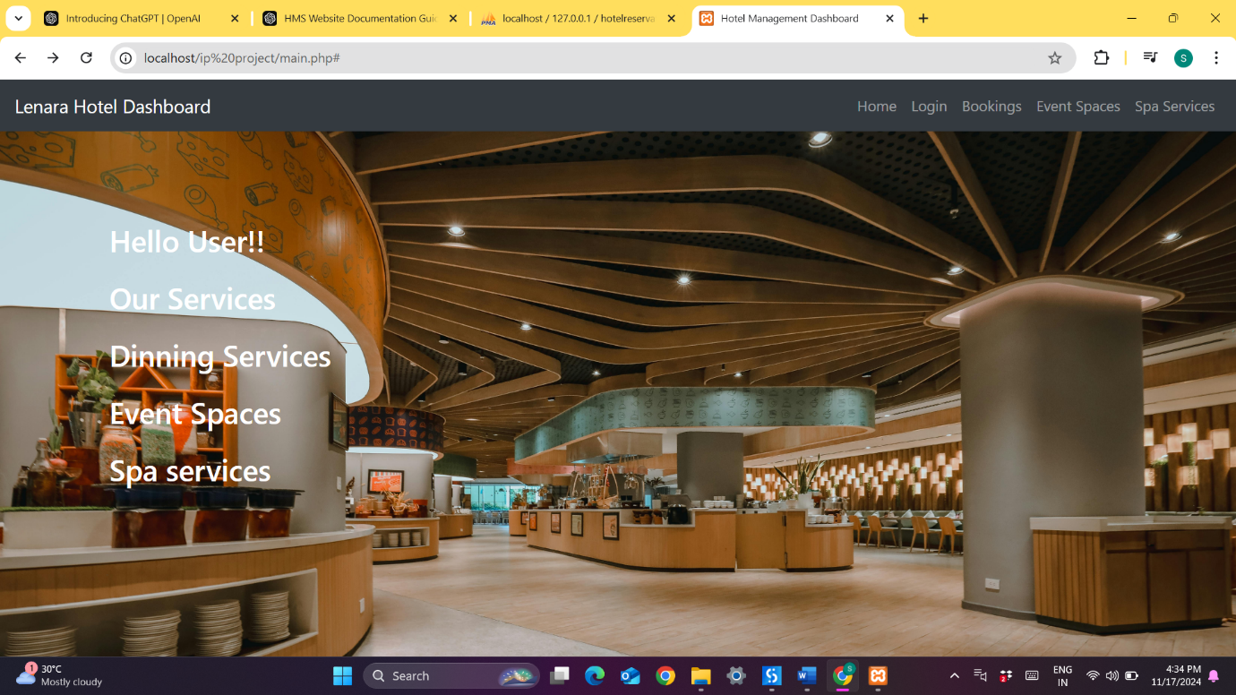

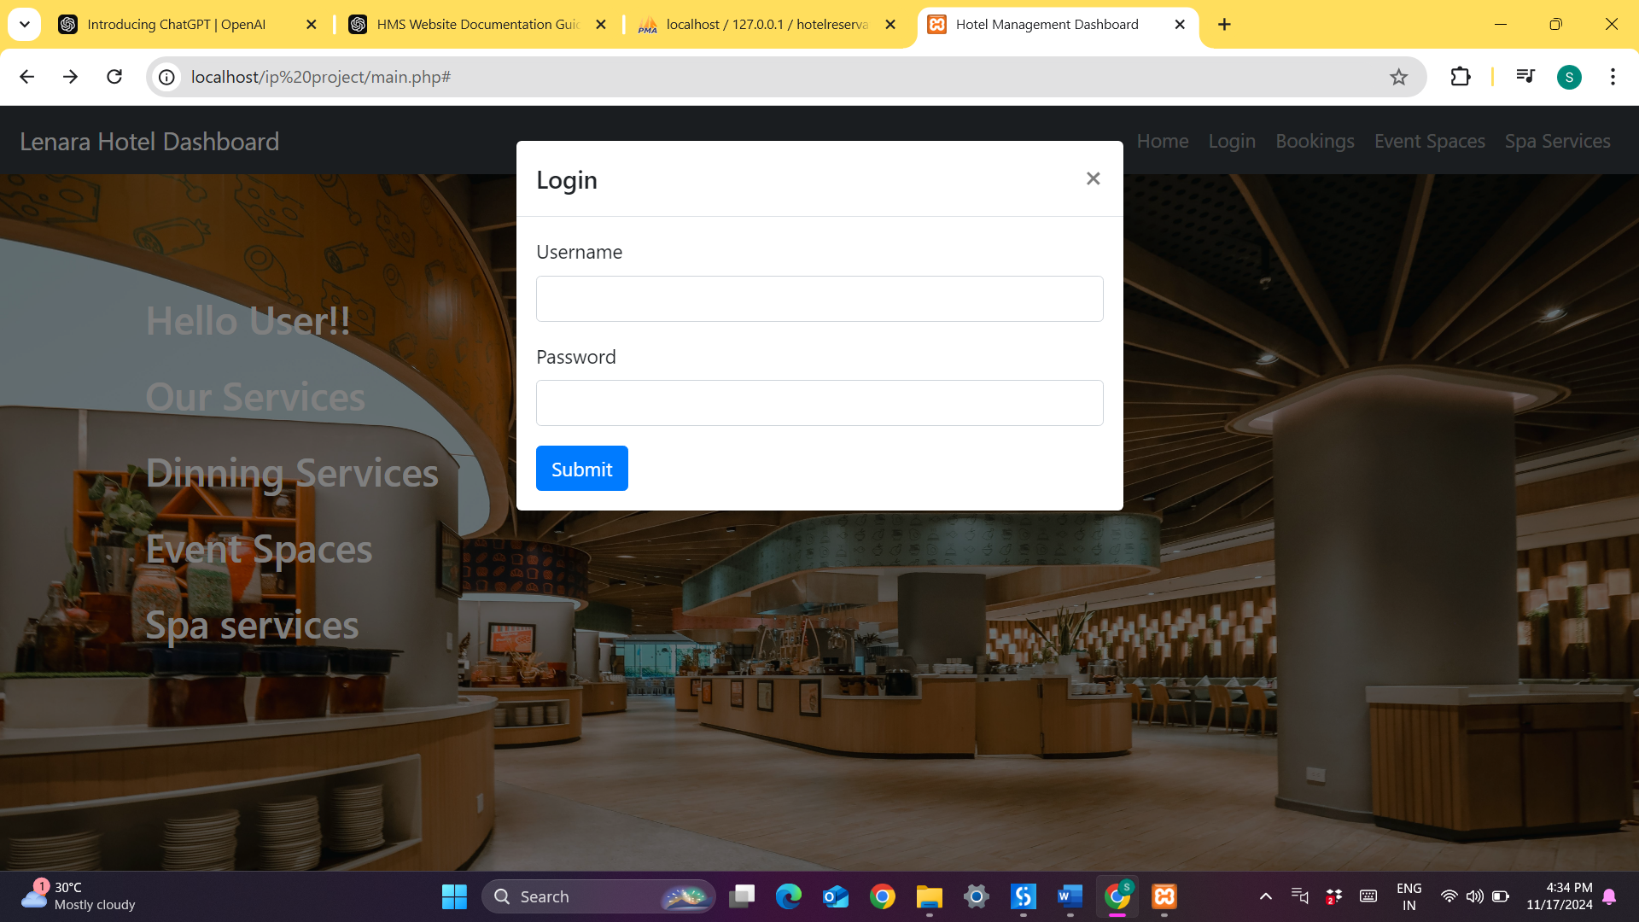

**3.2 Session Management**

The system uses session management to maintain user login status across pages. Once a user logs in, a session is created to store their login credentials securely. This session remains active during the user's visit, enabling access to booking and management features without re-authentication. Sessions automatically expire after a specified period of inactivity, enhancing security by logging users out after extended idle time.

**4. Dining Service**

**4.1 Booking Functionality**

The dining service booking allows users to reserve tables in the hotel’s dining area. Users can specify:

* **Date** and **Time** of the reservation.
* **Diet prefences for the guests.**
* **Table Layout**: Users can select from available table arrangements, including members count and location, if applicable.

The system checks available slots based on the selected date and time to prevent overbooking. After confirmation, users receive a booking ID along with the booking info for future reference.

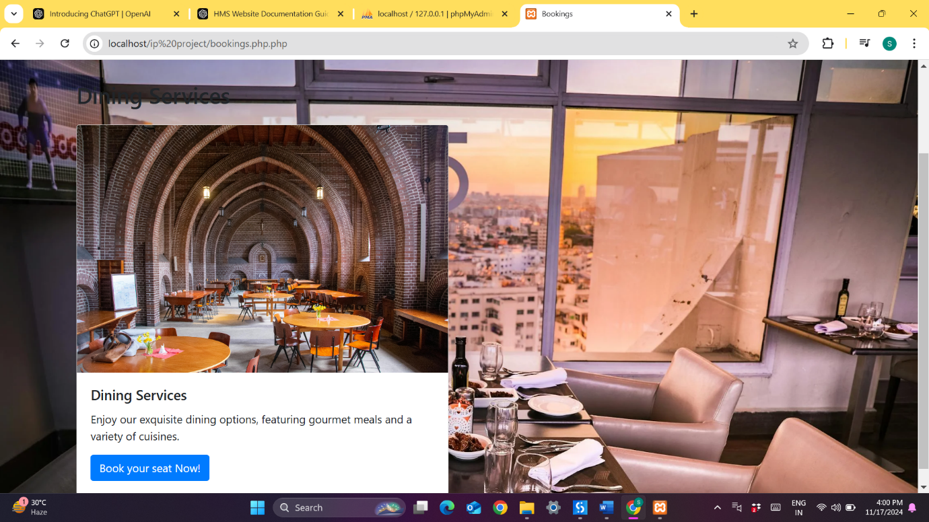

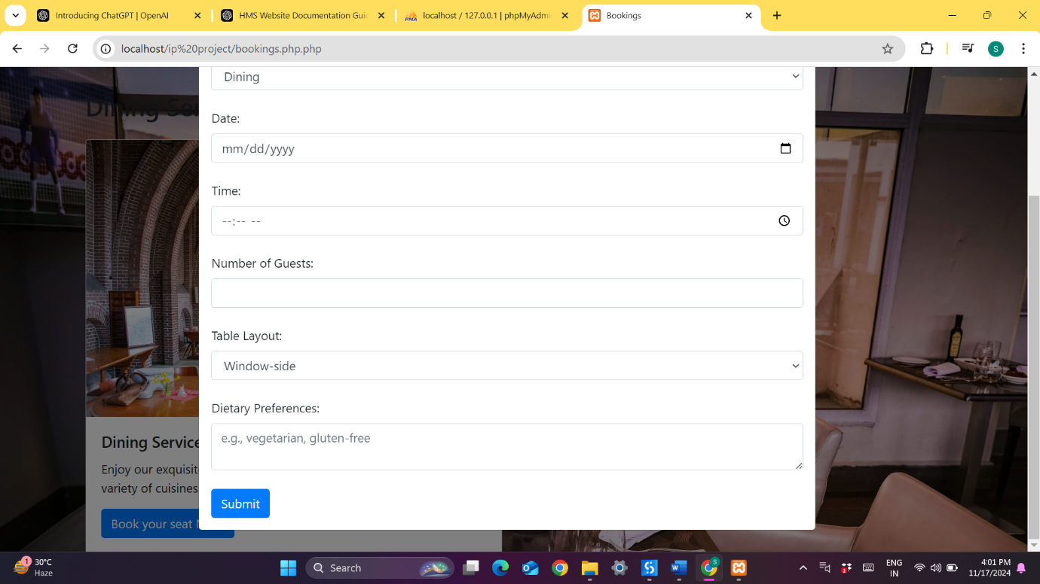

**4.2 Update and Delete Options**

Users can easily modify or delete their dining reservations:

* **Update**: Users can change their reservation date, time, or table layout by accessing their booking history.
* **Delete**: Users can cancel reservations, freeing up slots for other guests. Upon cancellation, users receive a confirmation email or notification

**5. Event Hall Booking**

**5.1 Booking Functionality**

Event hall bookings allow users to reserve a hall for various occasions. Users can select:

* **Date** and **Time**: Users choose the event date and starting and ending times.
* **Event Type**: Options might include wedding, conference, party, etc., which can help tailor the booking to specific requirements.

Once the booking is confirmed, users receive a unique reservation ID and a summary of their event hall booking.

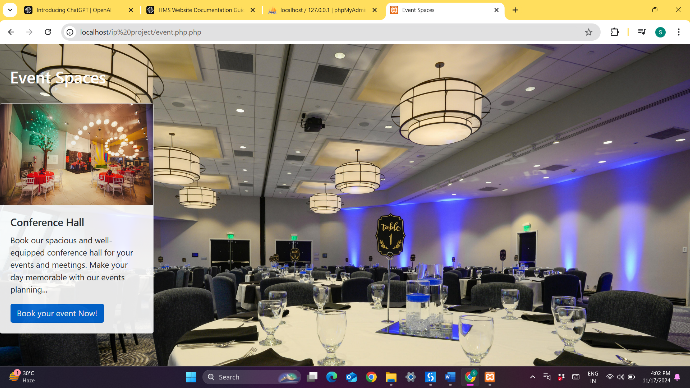

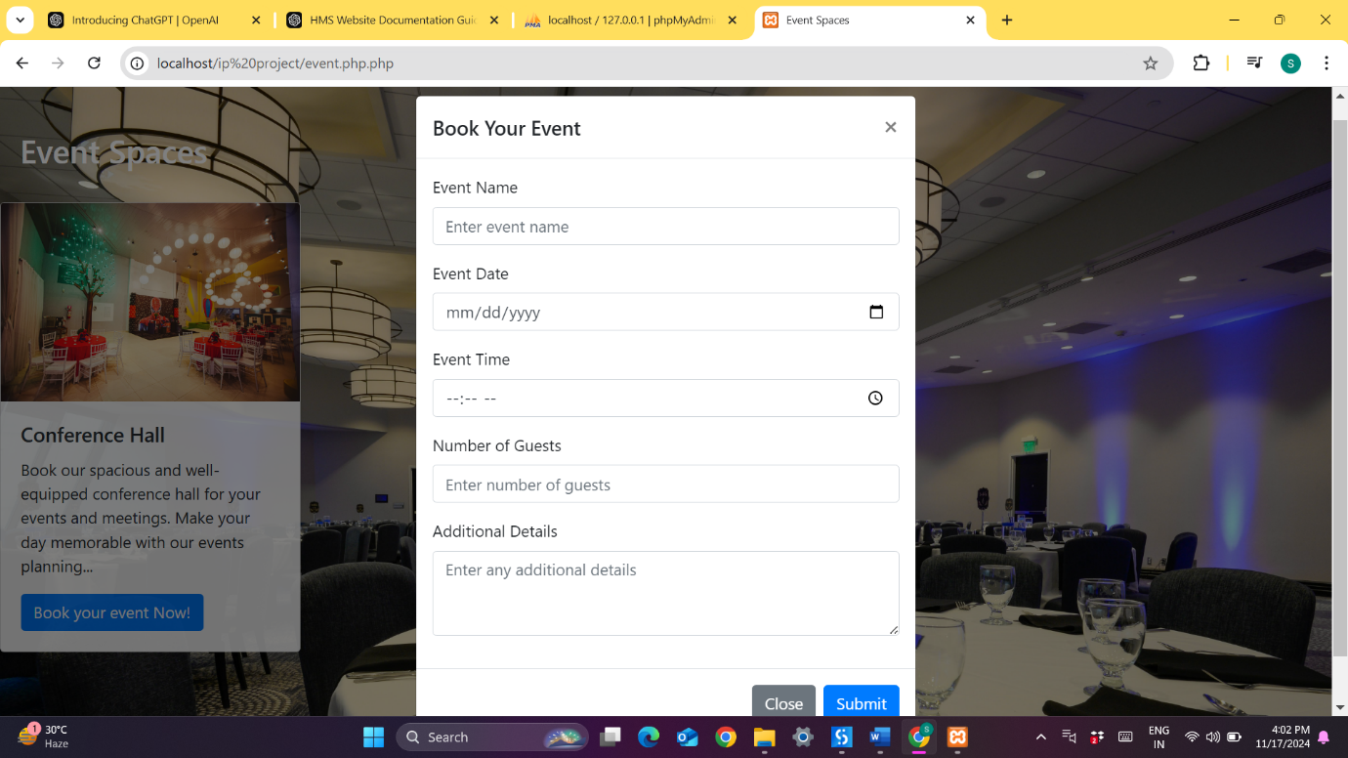

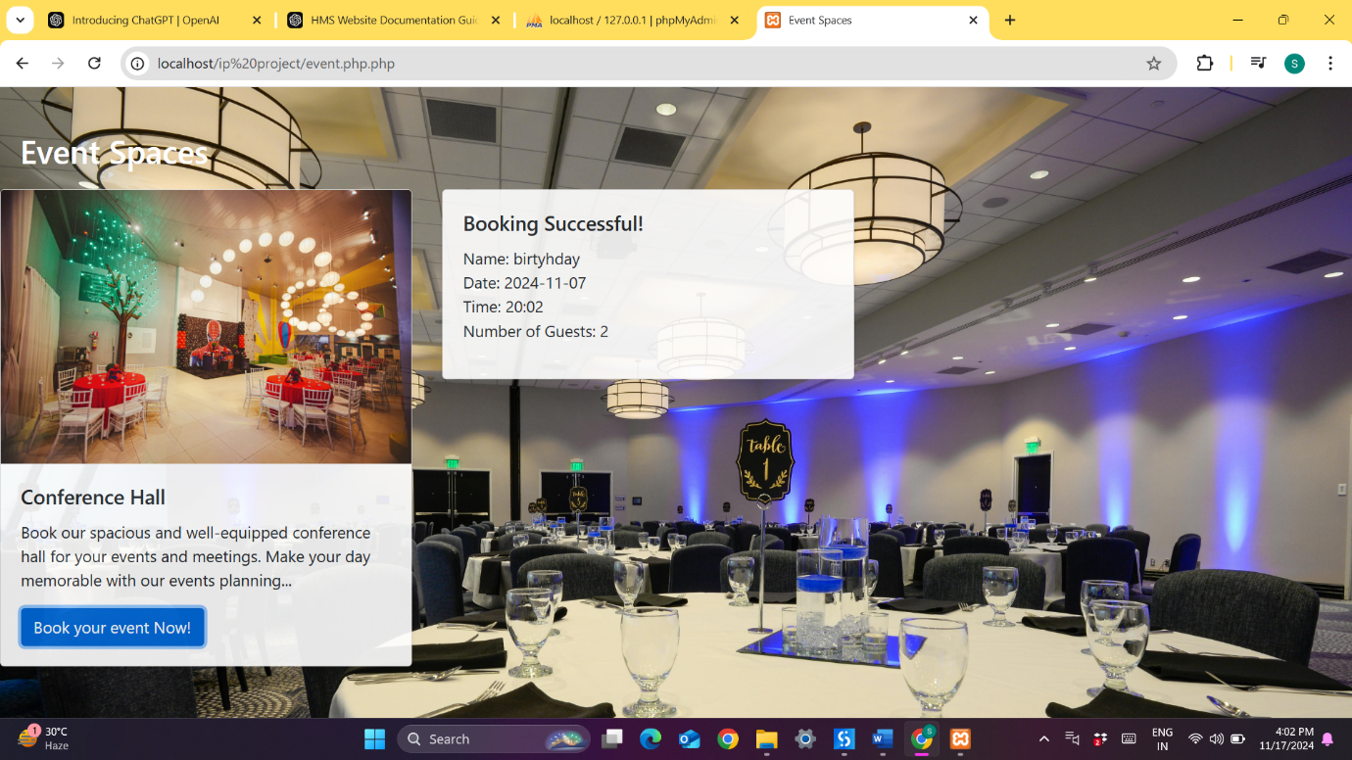

**5.2 Update and Delete Options**

Users have the flexibility to modify or cancel their event hall reservations:

* **Update**: Users can change details like date, time, or event type, as long as the changes comply with availability.
* **Delete**: Users can cancel their reservation, freeing up the slot for other events.

**5.3 Custom Requirements**

Depending on the event type, users may have customization options, such as Users can specify these details during booking, and the event name and the team size is notified accordingly.

**6. Spa Service with Availability Check**

**6.1 Booking Functionality**

Users can book spa appointments by selecting:

* **Date** and **Time**: Users pick the date and preferred time slot for their spa session.
* **Treatment Type**: Options may include massages, facials, or other spa treatments.

Once booked, users receive a confirmation email or message with details about their spa appointment.

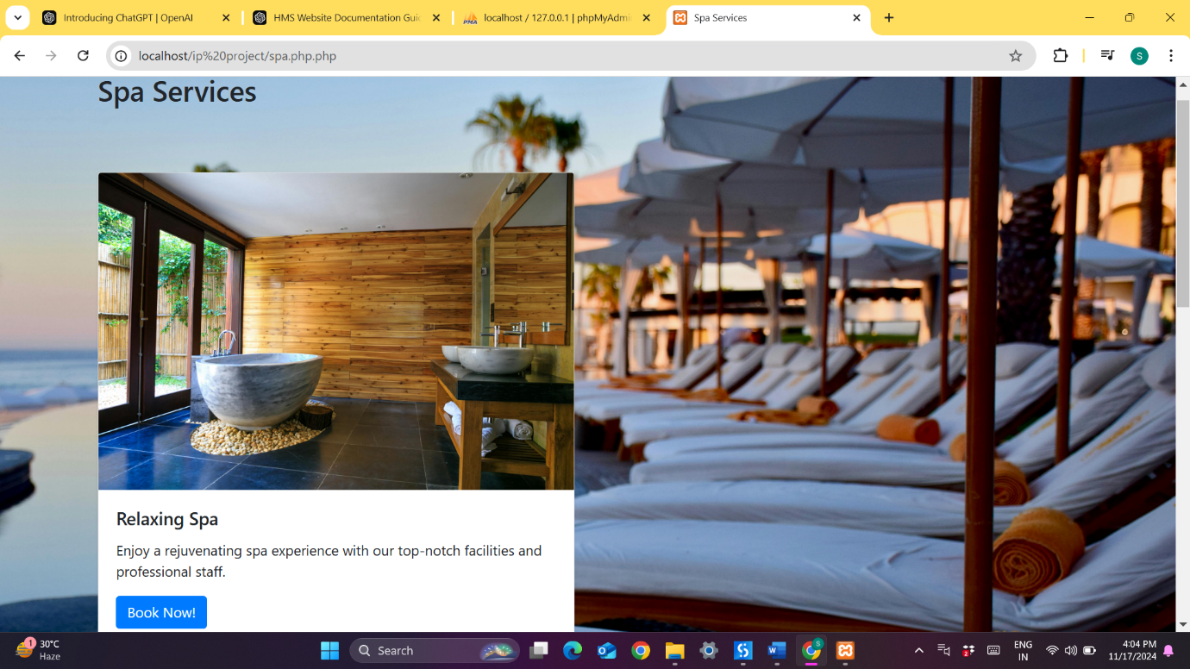

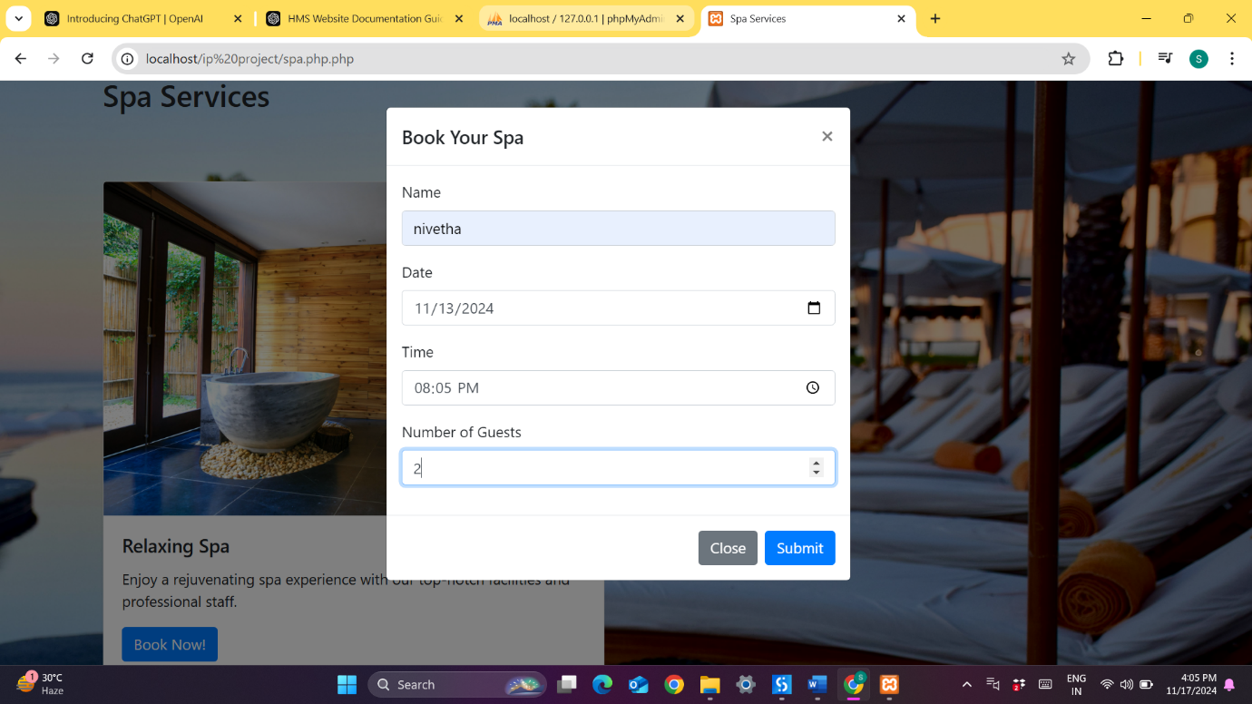

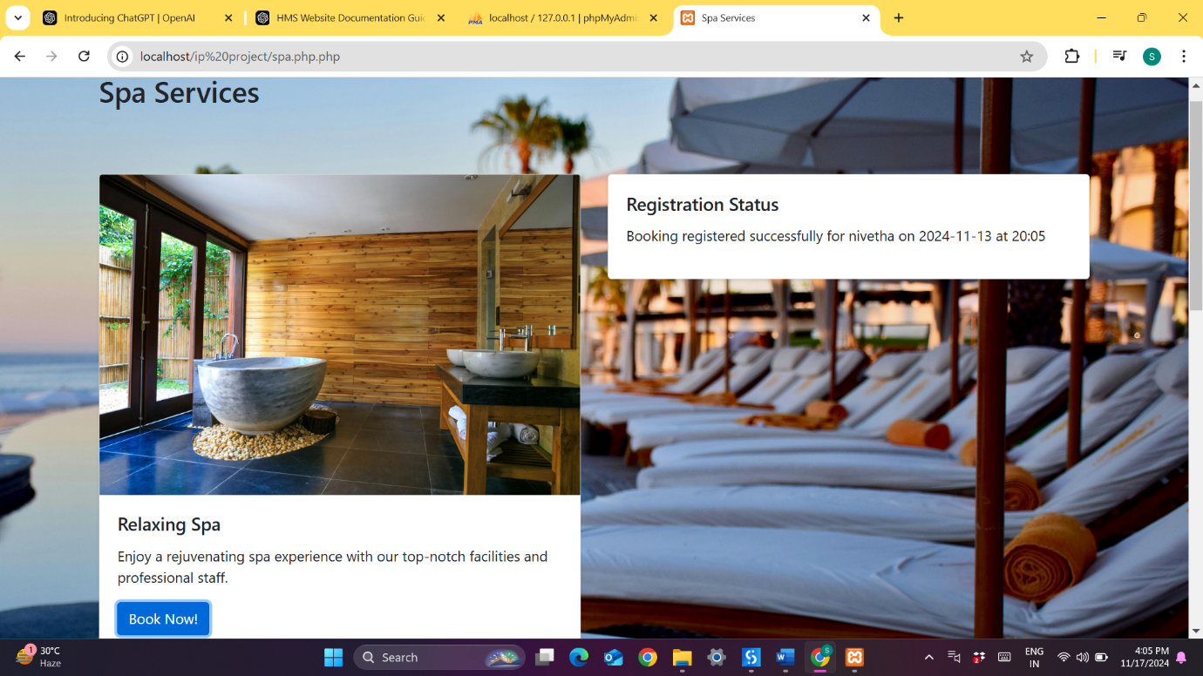

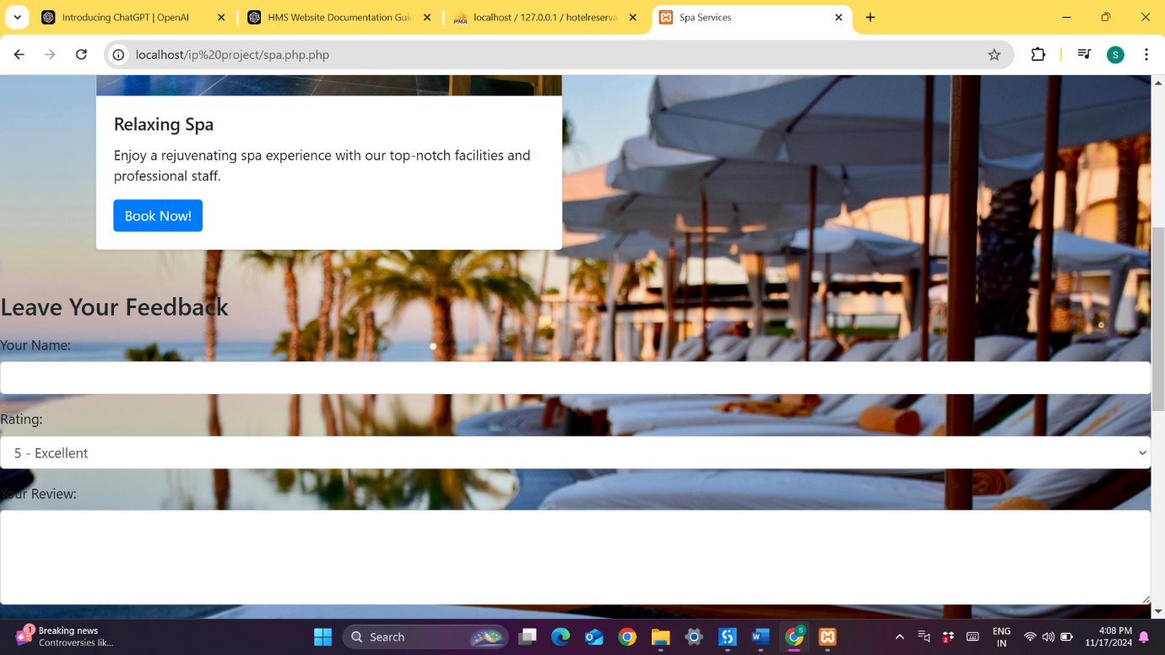

**6.2 Real-time Availability Check**

To manage limited spa capacity, the system checks the availability of each time slot in real-time. If a slot is already fully booked, the system displays a “Booking is Full” notification, prompting the user to choose a different time or date.

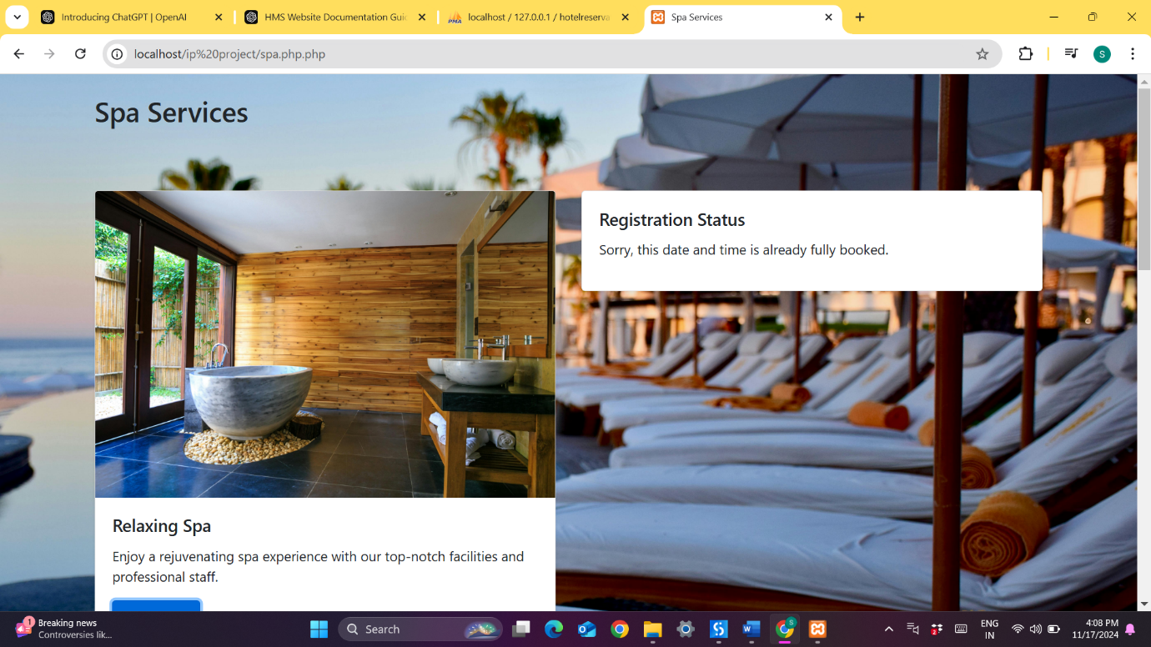

**6.3 Update and Delete Options**

Users can manage their spa appointments:

* **Update**: Users can change the date, time, or treatment type if the new slot is available.
* **Delete**: Users can cancel their appointment, freeing up the slot for other guests. Cancellation confirmation is sent to the user.
* 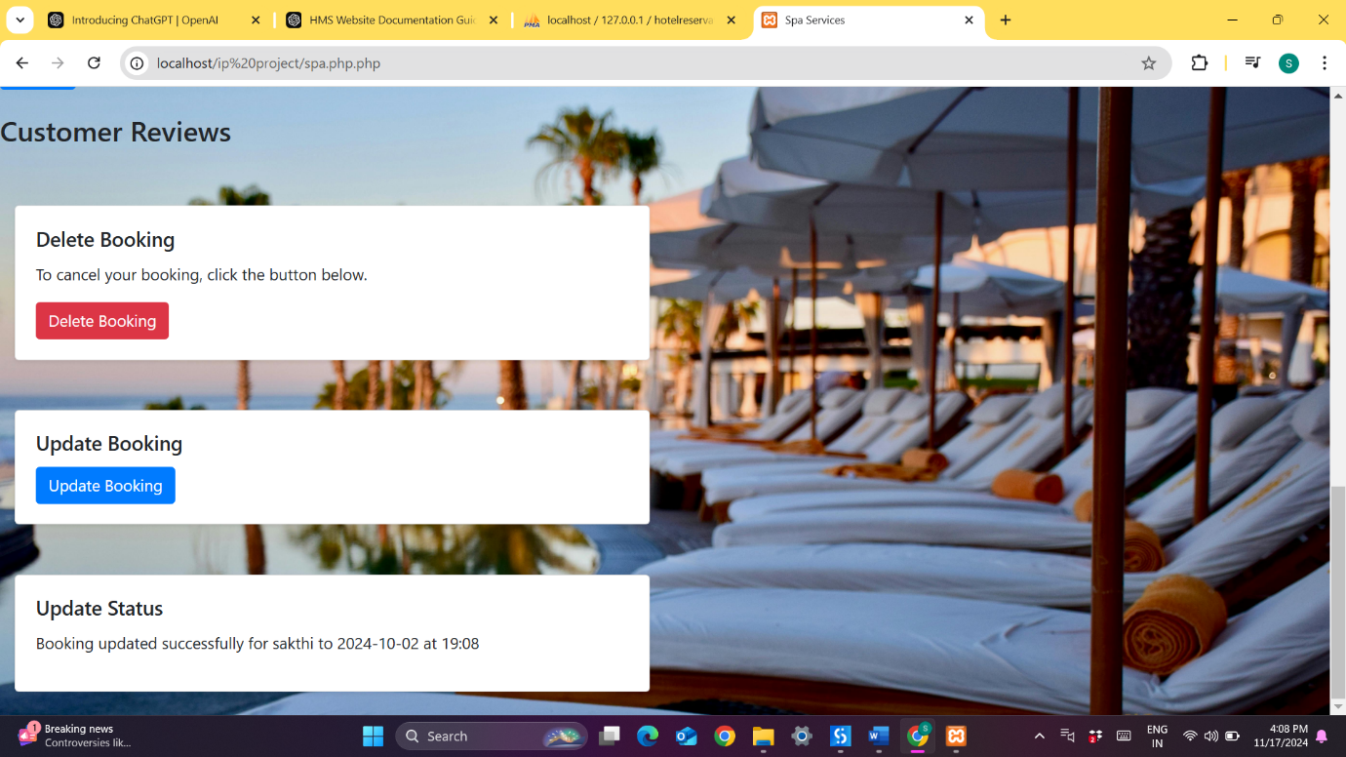
* 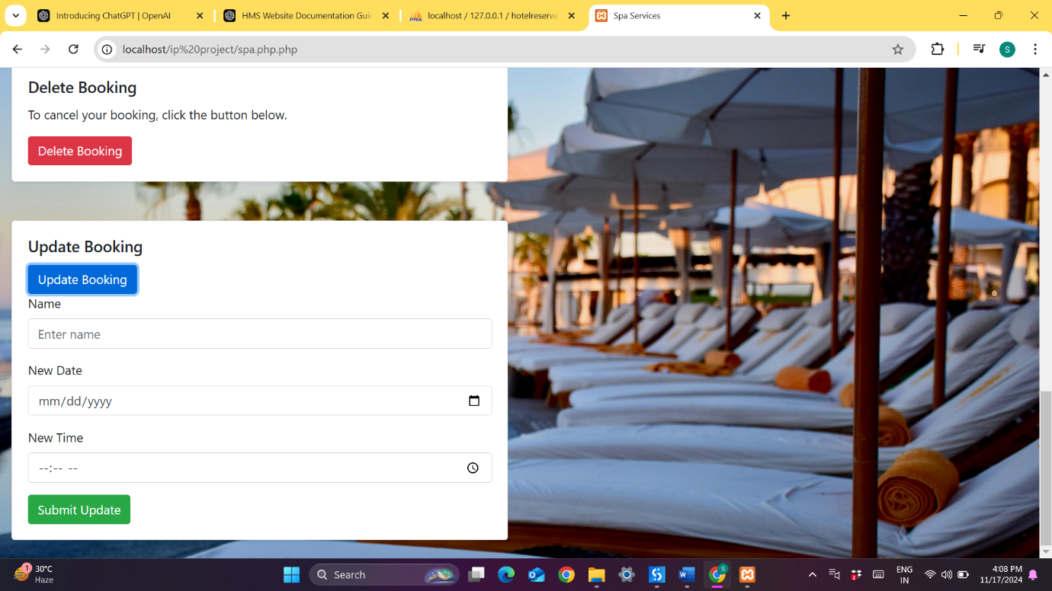
* 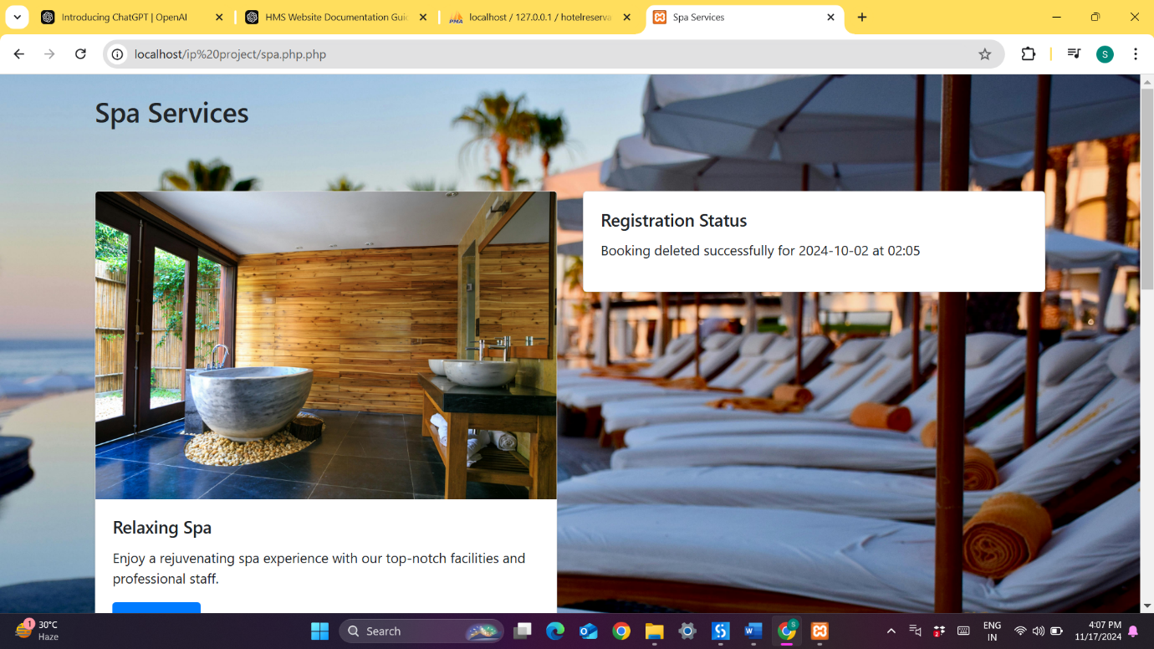

**7. System Features for Each Service**

The hotel management system includes various features to ensure smooth booking experiences for each service:

**7.1 Booking System**

Each service (Dining, Event Hall, Spa) provides a user-friendly interface for selecting dates, times, and additional preferences. Users receive a unique booking ID for each reservation, which can be used for future reference or modifications.

**7.2 Update and Modify System**

Users have the option to update bookings for each service as long as they remain within the guidelines and availability limits of the system. Modifications are logged, and confirmation messages are sent to users to keep them informed of changes.

**7.3 Cancellation System**

Users can cancel bookings for any service, freeing up slots for other guests. Cancellations are confirmed through email or notifications, ensuring clear communication between the user and the hotel.

**7.4 Real-time Availability and Notifications**

The spa service includes a real-time availability check to prevent double-booking. Users receive notifications for each action taken in the system—booking confirmation, updates, cancellations, or unavailability messages. These notifications are essential for keeping users informed and providing them with an exceptional experience on the platform.

**8. Database Structure**

**8.1 Database Tables**

The hotel management system’s database is structured to handle user information, bookings, and availability. Each table is designed to store and retrieve data efficiently. Here is a brief description of the main tables:

* **Dining_Bookings**: Holds dining reservations, with columns like diet preferences,date ,time,guests count and status.
* **Event_Hall_Bookings**: Manages event hall bookings with details such as event date,event time, event name , guests count and status.
* **Spa_Bookings**: Records spa appointments, containing booking_id, user_id (foreign key to Users), date, time, guests count and status. Additionally, it tracks booking limits for each slot.
* **Spa_Availability**: A helper table specifically for spa bookings, where date, time fields help manage and monitor availability for each slot.

**8.3 Handling Availability in Spa**

Availability for spa services is managed in the **Spa_Availability** table:

* **Date and Time Slots**: Each record in the Spa_Availability table corresponds to a unique date and time slot.
* **Real-time Updates**: As appointments are modified or canceled, the availability count is adjusted accordingly to reflect real-time availability.

**9. Error Handling and User Notifications**

**9.1 Error Handling**

The system implements robust error-handling mechanisms to ensure smooth operation. Some of the potential error scenarios and their management are:

* **Booking Full Slot**: If a user attempts to book a slot that is already full (especially in the spa service), the system will display a “Booking is Full” message, prompting the user to choose a different slot.

.

* **Duplicate Booking Requests**: The system checks if the user has an existing booking at the same time to prevent duplicate entries, notifying the user of any conflicts.
* **System Downtime**: If the server is down or under maintenance, users will see a “System Unavailable” message. A notification is also displayed indicating when the system is expected to be available again.

**9.2 User Notifications**

The system provides timely notifications to users for each significant action, enhancing the user experience and keeping them informed. Notifications are sent via email and/or displayed on-screen, covering:

* **Booking Confirmation**: After a successful booking, users receive a confirmation message with booking details is displayed on the screen.
* **Updates and Cancellations**: Users are notified of successful updates or cancellations, ensuring that any changes are reflected accurately.
* **Full Booking Alert**: If a chosen slot is full, especially in the spa service, users are alerted immediately to select a different time.

**10. Conclusion and Future Enhancements**

**10.1 Summary of Features**

The hotel management system incorporates a wide range of features to provide a seamless booking experience for dining, event hall, and spa services. Key functionalities include user login and registration, session management, real-time availability checks, and the ability to book, update, and delete reservations across all services. Error handling and user notifications ensure smooth user interaction and system reliability.

**10.2 Future Enhancements**

To further improve user experience and enhance the system, the following features could be implemented in future versions:

* **Automated Email Reminders**: Send automated reminders closer to the booking time to reduce no-shows.
* **Feedback Forms**: Allow users to provide feedback after each service, helping the hotel improve quality and service.
* **Loyalty Program**: Implement a points-based system for frequent bookings, where users can earn and redeem points for services.
* **Advanced Reporting for Admins**: Develop analytical reports that give hotel staff insights into booking trends, peak times, and user preferences.
* **Mobile App Integration**: Expand the system to include a mobile app for easier access and on-the-go booking capabilities.

Top of Form

Bottom of Form